Using Newton-Raphson’s Method on Crank Mechanism

# Introduction

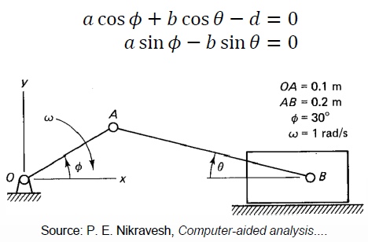The task was about creating a program in MATLAB, that plots displacement, velocity and acceleration of a connecting rod and a piston of a Slider Crank Mechanism.

# Solution for constant $ϕ$

$$x=\left[{θ \atop d}\right], \dot{x}=\left[{\dot{θ} \atop \dot{d}}\right], \ddot{x}=\left[{\ddot{θ} \atop \ddot{d}}\right], ϕ=30°=\frac{π}{6} .$$

$f\left(x\right)=\left[\begin{matrix}a cos ϕ+b cos θ-d \\ a sin ϕ-b sin θ\end{matrix}\right]=0$, constrain equations.

Solution for $x=$ $\left[{ 0.2527 \atop 0.2803}\right]$,

$J=\left[\begin{matrix}-b sin θ & -1 \\ -b cos θ & 0\end{matrix}\right]$ Jacobian.

$\dot{f}\left(x\right)=\left[\begin{matrix}-a \dot{ϕ} sin ϕ-b \dot{θ} sin θ-\dot{d} \\ a \dot{ϕ} cos ϕ-b \dot{θ} cos θ\end{matrix}\right]=0$. First time derivative (velocity), where $\dot{ϕ}=ω=1\frac{rad}{s}$ and is constant.

This can be also represented in a form $J \dot{x}=-f_{ϕ}$, where the terms associated with the known crank velocity are moved to the right side:

$\left[\begin{matrix}-b sin θ & -1 \\ -b cos θ & 0\end{matrix}\right]\left[\begin{matrix}\dot{θ} \\ \dot{d}\end{matrix}\right]=\left[\begin{matrix}a \dot{ϕ}\sin{ϕ} \\ -a \dot{ϕ}\cos{ϕ}\end{matrix}\right]$. Solution for $\dot{x}=$ $\left[{ 0.4472 \atop -0.0724}\right]$.

$\ddot{f}\left(x\right)=\left[\begin{matrix}-a {\dot{ϕ}}^{2} cos ϕ-b \ddot{θ} sin θ-b {\dot{θ}}^{2} cos θ-\ddot{d} \\ -a {\dot{ϕ}}^{2} sin ϕ-b \ddot{θ} cos θ+b {\dot{θ}}^{2} sin θ\end{matrix}\right]=0$. Second time derivative (acceleration).

This can be also represented in a form $J \ddot{x}=G$, where the terms associated with the known crank acceleration and the quadratic velocity are moved to the right side:

$\left[\begin{matrix}-b sin θ & -1 \\ -b cos θ & 0\end{matrix}\right]\left[\begin{matrix}\ddot{θ} \\ \ddot{d}\end{matrix}\right]=\left[\begin{matrix}a {\dot{ϕ}}^{2} cos ϕ+b {\dot{θ}}^{2} cos θ \\ a {\dot{ϕ}}^{2} sin ϕ-b {\dot{θ}}^{2} sin θ\end{matrix}\right]$. Solution for $\ddot{x}=$ $\left[{-0.2066 \atop -0.1150}\right]$.

# Program

A program Crank_Mechanism.m was created, which calls function NR_method.m. In the beginning of the program, parameters and time vector is defined. Next, initial guess and tolerance for the solution of the equations is set. The vectors of displacement *x*, velocity *v* and acceleration *aa* are initialized with zeros to match size of the time vector.

After that, function *for* is used to call one by one each element of the vector *phi*, which corresponds to the angle of rotation of the crankshaft and save it to corresponding row of each wanted vectors *x*, *v* and *aa*. These vectors are computed using function NR_method.m, which uses Newton-Raphson’s method to solve systems of nonlinear algebraic equations. Above mentioned equations are used in its input. Finally, these vectors are saved to extra variables and then plotted.

# Results

The results for constant angular velocity $ω=1\frac{rad}{s}$, time interval (0, 10 s), $phi= \frac{π}{6}+ω t$, tolerance ${10}^{-4}$ and initial guess $\left[{0 \atop 0}\right]$ looks like this:

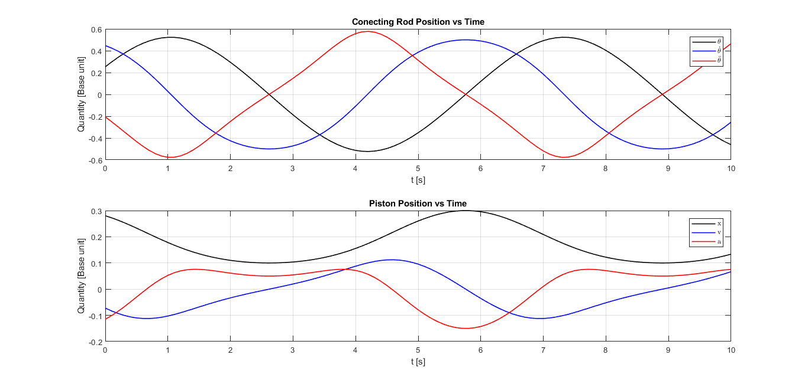

# Conclusions

All sources were pushed to GitHub. Link to the repository is: https://github.com/q2493/HW_4_Jakub_Trusina

The correct results very depend on initial guess. For example, with initial guess $\left[{1 \atop 1}\right]$ solution diverge:

